NUACA REPORT
On "Projects Management (application in Tourism)"
held at the NUACA within the HERITAG Erasmus+ project
The “Projects Management (application in Tourism)” course developed within the framework of HERITAG Erasmus+ project has been organized at the National University of Architecture and Construction of Armenia (NUACA) for students of 4th year bachelor's and master's degree programs students from May 29 to June 4, 2018 (Figure 1). Course description and Schedule are attached (see Annex 1). The course was developed and conducted by the NUACA instructors (M. Ghazaryan, V. Hovhannisyan, I. Vanyan, G. Avetisyan) (Figure 2) which are certified by New Jersey Rutgers University (USA) as instructors of “Project Management”. More than 25 course participants (signed attendance list is attached in Annex 2) forming 6 small groups developed and presented the project conceptual papers for tourism field defense of which took place on June 4th, 2018.
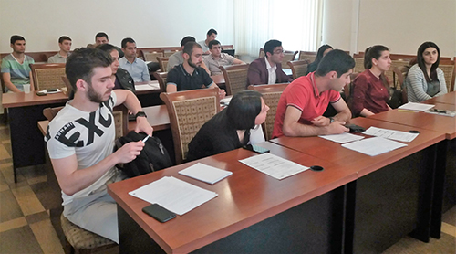
Figure 1. Participants of the training course titled “Project Management (application in Tourism)” that was held at the NUACA on May 29 – June 4, 2018 for students of 4th year bachelor's and master's degree programs students.

Figure 2. Instructors of the training course titled “Project Management (application in Tourism)” (in the left – V. Hovhannisyan, in the right – I. Vanyan).
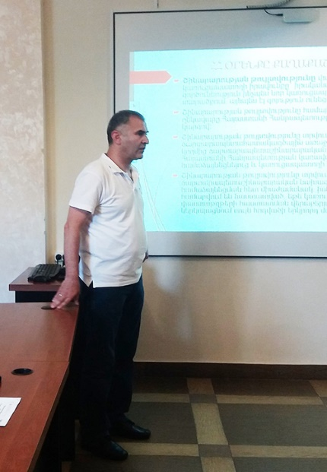
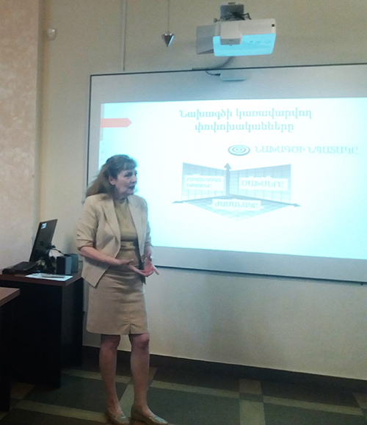

Annex 1. «Project Management (application in Tourism)» Course Description
Short Course for Bachelor and Master Programs’ Students

General Information
University |  | National University of Architecture and Construction of Armenia (NUACA) and Armenian National University of Economics (ASUE)
Course title |  | Project Management (application in Tourism)
Course/Module code
Course type |  | Short course
Credits awarded (ECTS) |  | 2 Credits
Dates and duration (hours) |  | 29.05.18 – 4.06.18 (4 hours per day x 5 days = 20 hours + 40 hours for project development)
Entry requirements/  Competences |  | Students of 4th year of Bachelor Course and Master Program
Responsible person/coordinator |  | V.Hovhannisyan / I. Vanyan
Where |  | National University of Architecture and Construction of Armenia (NUACA) (Yerevan)
Registration period |  | 23 April – 25 May, 2018
Max/Min students |  | 35/25
Lecturer’s details
Name, surname | I.Vanyan
Academic title | Associate Professor, PhD in Economics
e-mail | irinavanyan@gmail.com
Office hours and consultation schedule | Every Tuesday: from 11:00am to 13:00pm; every day available by e-mail from 17:00pm to 18:00pm.
Course Structure
Course Aim and Objectives | Course aim: This aims to helping students to understand and use in a practice the main principles and central components of tourism project concept development, select tools and processes appropriate to successful completion and defending of their tourism project concept paper.  Objectives:  - develop a tourism project charter  - plan of tourism project scope  - collect stakeholders’ requirements  - define tourism project scope  - create a work breakdown structure
Short Description | Offers insight into main definitions of tourism, types of tourism projects and how the tourism projects are defined, evaluated, and ultimately translated into manageable project requirements and concrete deliverables. The focus of this short course will be on helping students understand the main principles and central components of tourism project concept development, select tools and processes appropriate to successful completion and defending of their tourism project concept paper.

Module/Topic |  | Learning Outcomes | Teaching Method |  | Assignments and Literature | Form of Assessment | Schedule
Introduction to the Course. Syllabus presentation: Goals, objectives, learning outcomes, policies, assessment conditions. |  | К1, К2 | Interactive lecture by using of slide show presentation |  | [1] A Guide to the Project Management Body of Knowledge (PMBOK® Guide Fifth Edition). | Discussion in class, Q&A | 29.05.18  (11:15 -14:45)
Common introduction to the Tourism: What is tourism? Who is tourist? Types of tourism projects: local, national, international. Why it is important to understand tourism? |  | К1, К2 | Interactive lecture by using of slide show presentation. Exercises based on the students’ tourism project concept |  | [1] A Guide to the Project Management Body of Knowledge (PMBOK® Guide Fifth Edition).  [2] Vanyan, I.” Project Management”. Educational Textbook, Yerevan, Republic of Armenia, 2014. | Small groups’ work presentations | 30.05.18  (11:15 -14:45)
How to define the tourists’ preferences. Types of Tourism attractions: physical (tangible) cultural (intangible). Tourism components and motivations. The main definitions and terminology. Service dimensions of Tourism. |  | К1, К2, К3 | Interactive lecture by using of slide show presentation. Exercises based on the students’ tourism project concept |  | [1] A Guide to the Project Management Body of Knowledge (PMBOK® Guide Fifth Edition).  [2] Vanyan, I.” Project Management”. Educational Textbook, Yerevan, Republic of Armenia, 2014. | Small groups’ work presentations | 31.05.18  (11:15 -14:45)
How to develop the tourism project concept to ensure the meeting of assessment criteria: how to prepare a detailed scope statement, how to define the project goal, objectives, outcomes. |  | К2, К3, S1, S2, S3 | Interactive lecture by using of slide show presentation. Exercises based on the students’ tourism project concept |  | [1] A Guide to the Project Management Body of Knowledge (PMBOK® Guide Fifth Edition).  [2] Vanyan, I.” Project Management”. Educational Textbook, Yerevan, Republic of Armenia, 2014. | Small groups’ work presentations | 1.06.18  (11:15 -12:50)
How to develop the tourism project concept to ensure the meeting of assessment criteria: how to create Work Breakdown Structure (WBS) from the scope statement, how to define the project risks, etc. |  | К2, К3, S1, S2, S3 | Interactive lecture by using of slide show presentation. Exercises based on the students’ tourism project concept |  | [1] A Guide to the Project Management Body of Knowledge (PMBOK® Guide Fifth Edition).  [2] Vanyan, I.” Project Management”. Educational Textbook, Yerevan, Republic of Armenia, 2014. | Small groups’ work presentations | 1.06.18  (13:10 -14:45)
Presenttions of Projects’ concepts by students |  | K1, K2, K3, S1, S2, S3, A1, A2, A3 | Discussion of teams, tourism projects’ concepts assessment. |  | [1] A Guide to the Project Management Body of Knowledge (PMBOK® Guide Fifth Edition).  [2] Vanyan, I.” Project Management”. Educational Textbook, Yerevan, Republic of Armenia, 2014. | Q&A, discussion. | 4.06.18
Teaching and Assessment Requirements |  |  |  | Teaching: The students of the short course should abide the following requirements: attending the classroom for lectures, active participation in class discussions, group works, activating exercises, individual work and assignments execution. Students are expected to attend all class sessions as listed on the course calendar. The best way to contact Instructor outside of the class hours is via email because the important announcement and information about students’ performance (progress, scores, etc.) will be posted via e-mail. in order to help student to be able to catch up with the materials covered in the class every week, the outline of the weekly teaching for each topic will be provided to student via e-mail to help student to prepare for examination. Laptops, iPad and cell phones type devices are permitted for note-taking and course related material only. Food eating in class room is prohibited strongly because it is distracting to lecturer and other students. Battled water, coffee, tea, soft drink, etc. are fine, but users have to be considerate and do not leave trash. In case of spilling something it should be cleaned up by user. Students have to arrive to class on time. If student miss class, it is solely his/her responsibility to obtain the notes and/or materials given from a classmate. Academic honesty is expected.  Assessment: the individual tourism project concept passing is a mandatory for each student. Individual tourism project concept is a result of team work. Each team is a small group composed from 3-4 students. The concept paper of the project has to be developed by students’ team independently under instructor supervision. The tourism project concept paper has to be defended publicly with an appropriate Power Point Presentation as a mandatory. The fellow students have to assess the presented concept paper of each team based on the criteria below:  ## Criteria/Assessment scores Importance Indicator of Criterion Weighted Assessment Scores  1 The need and importance of the project are clearly formulated for the community Maximum 15  4 – excellent 15  3- good 11.25  2 – fair 7.5  1 –poor 3.75  2 The project goal, objectives and expected outcomes are clearly formulated Maximum 15  4 – excellent 15  3- good 11.25  2 – fair 7.5  1 –poor 3.75  3 Tourism attractions are justified Maximum 15  4 – excellent 15  3- good 11.25  2 – fair 7.5  1 –poor 3.75  4 The target group of tourists using the project service is defined clearly Maximum 10  4 – excellent 10  3- good 7.5  2 – fair 5  1 –poor 2.5  5 The project has innovative components Maximum 10  4 – excellent 10  3- good 7.5  2 – fair 5  1 –poor 2.5  6 The project cost is justified clearly Maximum 10  4 – excellent 10  3- good 7.5  2 – fair 5  1 –poor 2.5  7 The Power Point Presentation reflects the project concept completely and properly Maximum 10  4 – excellent 10  3- good 7.5  2 – fair 5  1 –poor 2.5  8 The positive impact of the project on the environment is justified clearly Maximum 5  4 – excellent 5  3- good 3.75  2 – fair 2.5  1 –poor 1.25  9 The audience questions regarding project presentation are answered adequate Maximum 5  4 – excellent 5  3- good 3.75  2 – fair 2.5  1 – poor 1.25  10 The project implementation duration is reasonable Maximum 5  4 – excellent 5  3- good 3.75  2 – fair 2.5  1 –poor 1.25  Total: 100
Resources |  |  |  | Computer, projector

Learning Outcomes
Knowledge | K1 - to present the fundamental knowledge in the field of tourism project management,  K2 - to present the main definitions concerned to the tourism project,  K3 - to present the tourism project management processes, particularly: plan scope management, collect requirements, define scope, create work breakdown structure (WBS), validate scope, control scope.
Skills | S1 - to develop the tourism project charter by using the contemporary approaches of project management,  S2 - to apply the main principles of tourism project management to practical situation,  S3 - to discuss the different case studies regarding the field of tourism project management,
Attitudes | A1 - to communicate with the stakeholders of the project with the purpose to identify their needs to define the scope of the project,  A2 - to exercise the skills in the field of WBS creation,  A3 - to demonstrate the capacity to control the project scope to give recommendations when trade-offs between project scope, cost, and schedule become necessary.

Literature:
Required reading:
[1] A Guide to the Project Management Body of Knowledge (PMBOK® Guide Fifth Edition).
[2] Vanyan, I.” Project Management”. Educational Textbook, Yerevan, Republic of Armenia, 2014.
Further reading:
[3] Project Management Book. http://www.hraconsulting-ltd.co.uk/project-management-book-0101.htm
[4] Project Phases. http://www.hyperthot.com/pm_fazes.htm
[5] The Project Life Circle. http://www.visitask.com/project-life-cycle.asp
[6] Project Management Kit. http://www.method123.com/project-management-kit.php?AID=066976
[7] Christensen, E. “How to Create a Work Breakdown Structure and Why You Should”. https://www.lucidchart.com/blog/how-to-create-a-work-breakdown-structure-and-why-you-should

Annex 2. Attendance List of training on “Projects Management (application in Tourism)” course.

